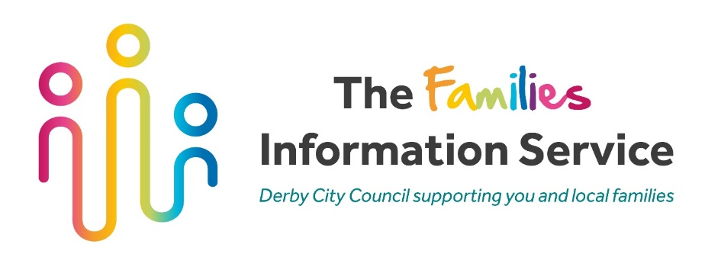

Save on the cost of childcare and holiday activities?

There are lots of ways you can make childcare and holiday activity schemes more affordable depending on your circumstances. Find out what you can save by using this handy calculator: www.gov.uk/childcare-calculator or use this QR code:
Save up to 20% on childcare and holiday schemes fees by using Tax Free Childcare.

- It is available to all working families, including those who are self-employed and have children under 12 (or under 17 if disabled).
- For every £8 you pay in, the government will add an extra £2, up to £2,000 per child per year - that’s up to £500 every three months.

For more information on local childcare and holiday activities, please contact the Families Information Service (FIS).

E: FIS@derby.gov.uk T: 01332 640758 F: @DerbyFIS
Signing service: derby.gov.uk/signing-service

For information on all the governments childcare support schemes, please visit www.childcarechoices.gov.uk

