Track the Coin Instructions

You will need
Coins, one each of: 1p, 2p, 5p, 10p, 20p, 50p and £1
A coin for spinning (to have it land heads or tails)
Counters, which can be Lego™ pieces, dried beans, wooden beads or even something edible like raisins!

How to play
- Line up the coins in the middle of the track.
- Take a counter each and place it on the start.
- Take turns to play.
- Use a different coin and spin it.
- If it lands heads, move 2 spaces.
- If it lands tails, move one space.
- If you land on an amount, read it aloud. Then point at the coin that matches it.
- If you are correct, you may stay on that space and take a counter.
- If you are incorrect, you must move back to where you started your turn.
- Take turns to play like this.
- If you land on a robber, he steals one of your counters!
- When you both reach the start again, count your counters.
- The winner has the most counters.

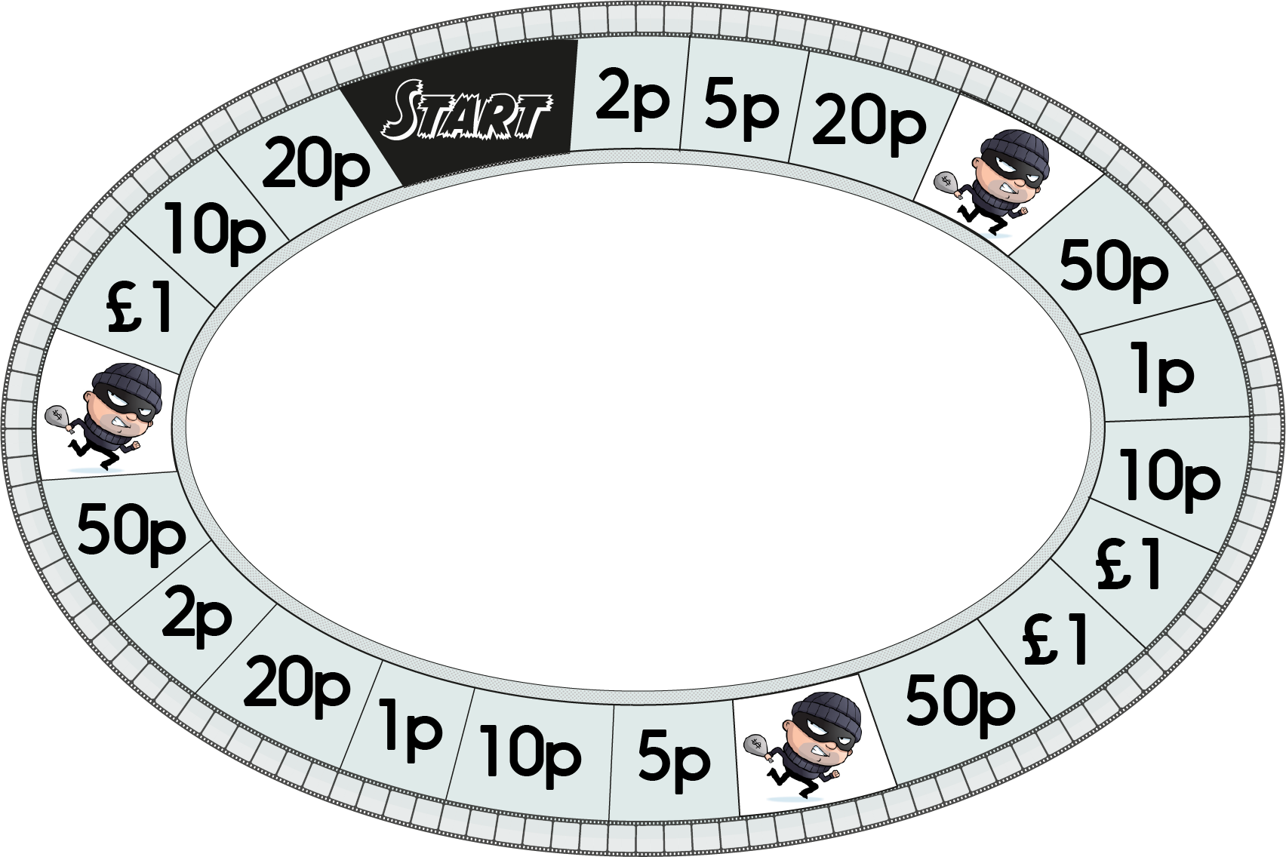
Track the Coin

