Five’s a Winner Instructions

You need 10ps, 2ps, 5ps, 1ps – two of each of the first three and four 1ps.
You also need the Amounts Cards and some paper and pencils.

NB If your child is not yet ready for numbers above 20, only use the Amounts Cards between 10p and 20p

How to play
- Cut out the Amounts Cards and spread these out, face down.
- Set out your coins so you can both see them clearly.
- Take turns to play.
- Choose a card. Turn it over.
- Read the amount.
- Take one or two 10p coins according to whether the amount begins with ‘1’ or ‘2’.
- Take the correct number of 1p or other coins to complete the amount.
- Ask your partner to check. Have you made the matching amount correctly?
- If yes, draw a £1 coin on your paper.
- Now your partner has a turn.
- Choose another card and repeat. Can you make all the amounts?

The winner is the person who has drawn the most £1 coins on their page!

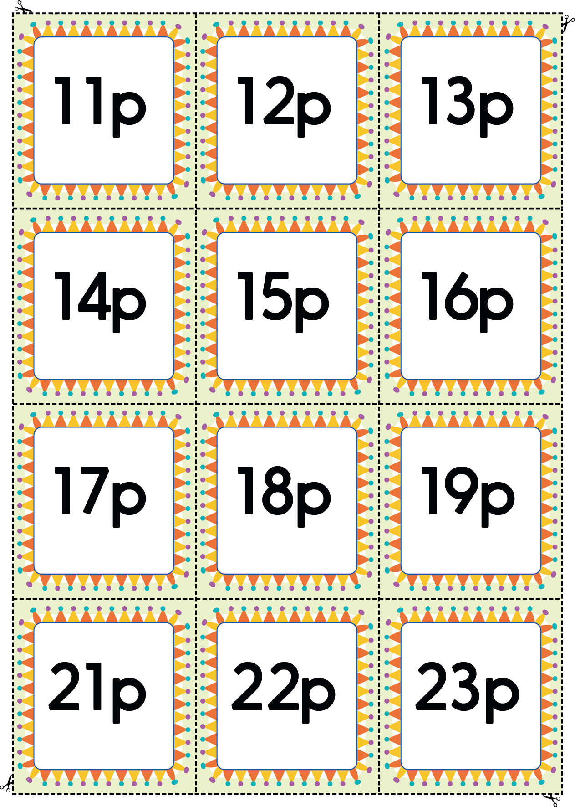
Amounts Cards
