Track the Order

You need: a counter each and a coin

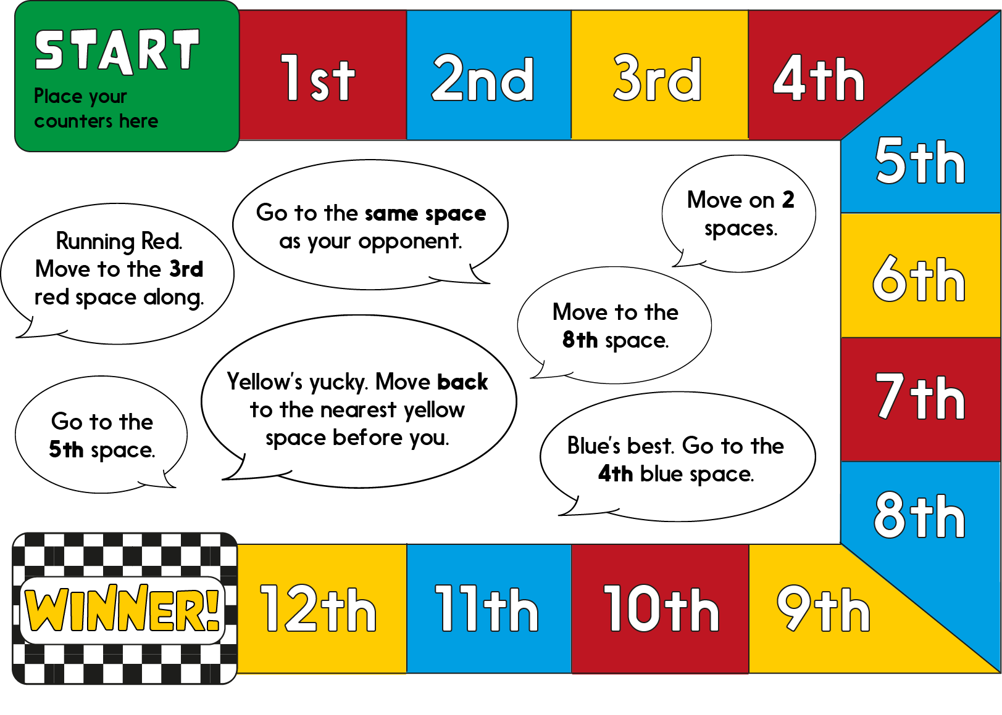
Instructions
  - Place your counters on Start.
  - Move by taking turns to spin the coin. Heads you move one space. Tails you stay put!
  - At any point, instead of spinning the coin, a player may elect to choose a speech bubble and obey its instruction.
  - No player may choose more than 4 speech bubbles in the whole game.
  - First person to get to Winner, wins!

