Superhero order

The 8 superheroes are in a line.
You are going to use the clues to put them in order from 1st to 8th.
HINT
Use 8 pieces of paper to make the 8 spaces in the line.
You will need:
Superhero counters from sheet below
Pens and paper to help you answer the questions

What to do
- Cut out the counters below.
- Follow the clues to place the superheroes in order.
- Then answer the questions.
Clues
Boy superhero comes before skinny cat
Skinny cat superhero is 5th

Fat cat superhero is 7th
Sweet dreams superhero is 1st

Long dog superhero is in between girl superhero and Sweet dreams

Fat superhero is behind Short dog
Baby superhero is last

Questions
- Which superhero comes after Short dog?
- Who is 3rd?
- Which superhero is 5th?
- Who is second in the line?
- Which superhero comes before Fat cat?

Superhero Counters
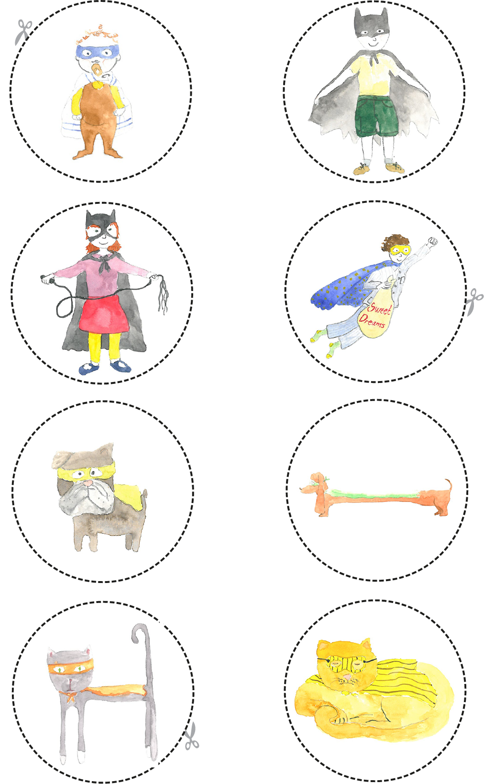
Cut round each counter.
Answers

The Superhero order is this.

Position | Superhero
1st | Sweet dreams superhero
2nd | Long dog superhero
3rd | Girl superhero
4th | Boy superhero
5th | Skinny cat superhero
6th | Short dog superhero
7th | Fat cat superhero
8th | Baby superhero

