Shapey Trail

You need:
- the track below printed out
- about a dozen small plastic animals/people or really tiny soft toys
- a coin to spin
- a counter each to move round the track

How to play

- Place the toys in the middle of the track.
- Place your counters on start.
- Take turns to spin the coin.
- If it lands ‘heads’, move two places forward.
- If it lands ‘tails’, move one space forward.
- When you have moved, say the name of the shape you have landed on.
- If you are correct, you take a small toy.
- If you are incorrect, discuss what shape it is, and then move back one space.
- Keep playing.
- When you both get back to the start, count your toys. The person with the most toys is the winner.
- Play again, timing yourselves. How fast can you get around the track, saying the correct shape names each time.

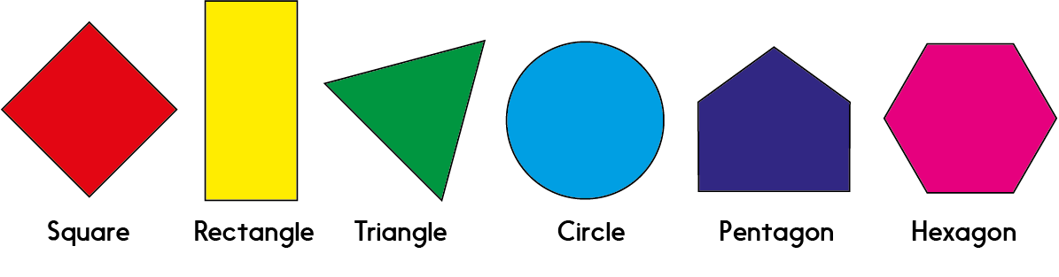

Shapey Trail
