Red, Yellow, Blue

You will need: nine small objects, three each of three colours. These can be Lego™ bricks, counters, beads, painted shells, or any other small coloured objects. The colours do not have to be red, yellow and blue. They can be any three different colours!

What to do

- You have to place all nine counters on the grid.
- You must follow the rules!
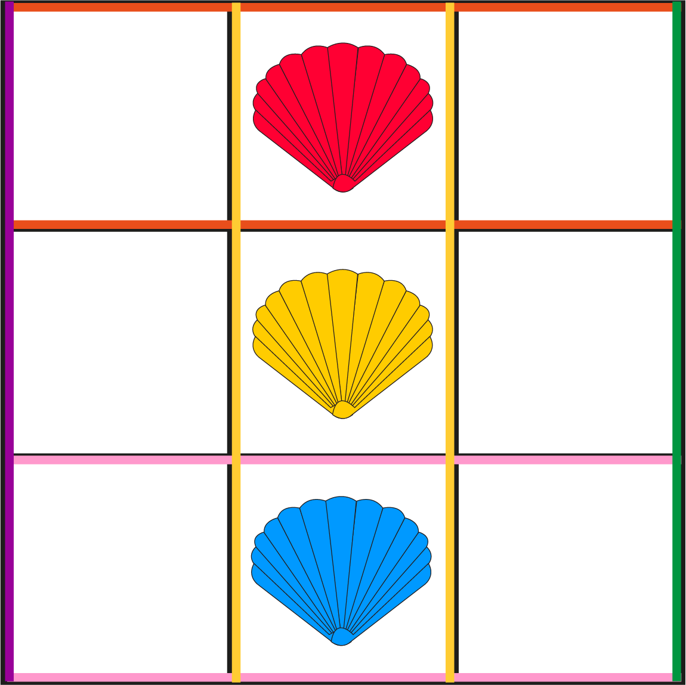 | RULES  - There must be exactly one yellow counter in every row and every column.  - There must be exactly one blue counter in every row and every column.  - There must be exactly one red counter in every row and every column.
HINT
Try to get the middle column in place first.
Then get the middle row in place.

- When you think you have done this, find someone else to check!
- Is there another, different way, of doing this?

