I really want to be a cat

I really want to be a cat,
what’s so very wrong with that?

I want to scratch and slink and prowl
but all I do is bark and growl.
I want to chase the birds and mice -
I know it isn’t very nice!

I want to jump upon the table
to steal some food when I am able.
I want to climb the highest tree
but solid ground is all I see.

I want to purr and go meow,
the problem is I don’t know how!
I want to prowl around at night
but all I do is get a fright.

I really want to be a cat,
what’s so very wrong with that?
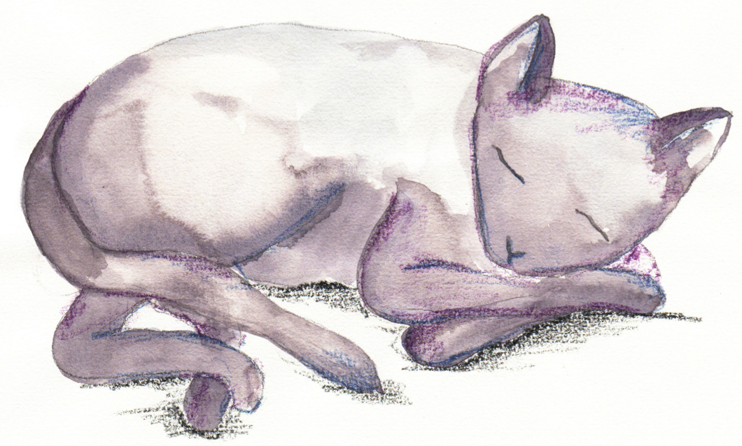
I really want to be a dog

I really want to be a dog

I really want to _________________________

I know it isn’t very nice!

I really want to _________________________

But ________________________________

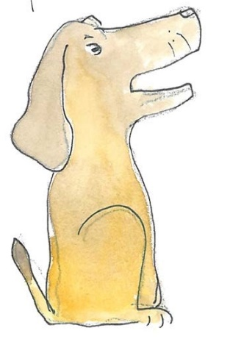
I really want to _________________________

I really want to
_________________________

What’s so very wrong with that?

Can you walk on tip-toe?

Can you walk on tip-toe
As softly as a cat?
And can you stamp along the road,
Stamp, stamp just like that?

Can you take some great big strides
Just like a giant can?
Or walk along so slowly
Like a poor crooked man?

Can you squeak so softly
As gently as a mouse?
And can you roar so boldly
Like a lion in the house?

