Make a Shape

You need:
- thin card or fat paper
- template (print next page)
- crayons or felt-tips
- PVA glue

In advance
- If you haven’t got any thin card, you can stick two pieces of paper together in advance with a little flour and water paste. Just mix a couple of tablespoons of flour with very little water, and stir hard to make a thick glue. Paint this thinly over a piece of paper and place another piece on top. Allow to dry.
- Print the templates. Cut these out really carefully.

What to do
- Lay the template on the card.
- Carefully draw round it.
- Lift the template from the page.
- Cut round your drawing carefully
(A child may want an adult to do some of the cutting!)
- Before you fold the shape, decorate each face.
- Fold the shape to make a box.
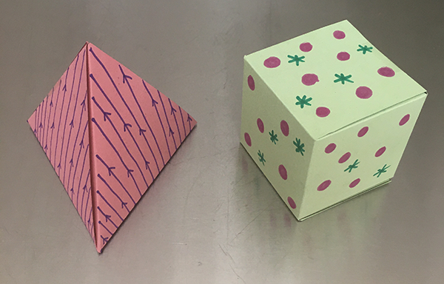

TEMPLATES
