Make a Do this number of actions! fortune teller

You need a square piece of paper, fat felt tip pens and a good pen for writing.

How to make it

- Fold your piece of paper along the diagonals.  - Press down so the creases are sharp.  - Open up the paper and then fold each corner into the middle.  - All four corners are now in the centre and you have a smaller square. | 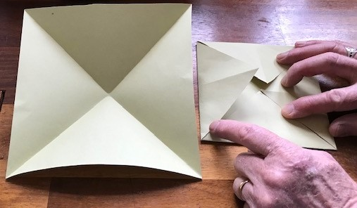
- Turn the smaller square over so the folds are underneath  - Repeat the above process, folding all the corners in to the centre.  - You should now have an even smaller square. | 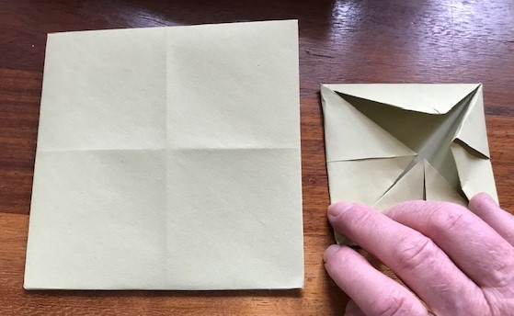
- Turn the square over so the folds are underneath  - Fold the square in half and press the fold down so it is a sharp crease.  - Fold the square in half the other way, and press the fold down. | 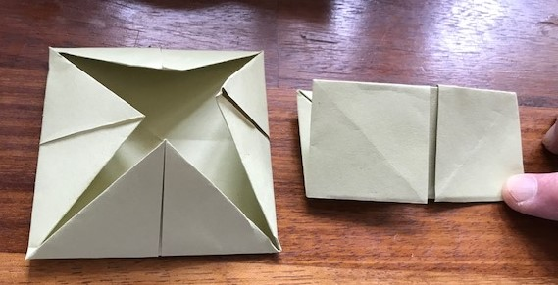
- You should now have a fortune teller. | 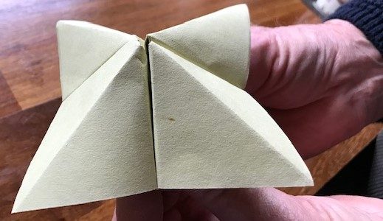

Instructions continued

- Place it flat on the table.  - Write numbers on the squares.  - Turn it over and colour the triangles.  - Each one should be a different colour.  - Now lift each triangle and write an action underneath it. Each one should have a different action.  - See suggested actions below…  - Fold it all back as it was, insert your thumbs and ask someone to choose a number. | 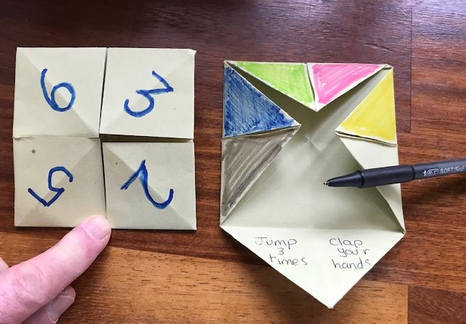
Suggested Actions

Jump 3 times Clap your hands 5 times Do 4 bunny hops

Do 6 wing flaps Stick out your tongue Wiggle your fingers

Take 8 steps on tiptoe Do a head-over-heels Hop 3 times

Say your name backwards Write your name backwards

Some sites which tell you how to use these are suggested below.
NB theirs are slightly different as they are used to ‘tell fortunes’.
Ours is just use to suggest actions which we can count!

https://www.youtube.com/watch?v=A42wubu8pJA

https://www.youtube.com/watch?v=BxyXk1sr2io

