Dinosaur Facts

Spinosaurus

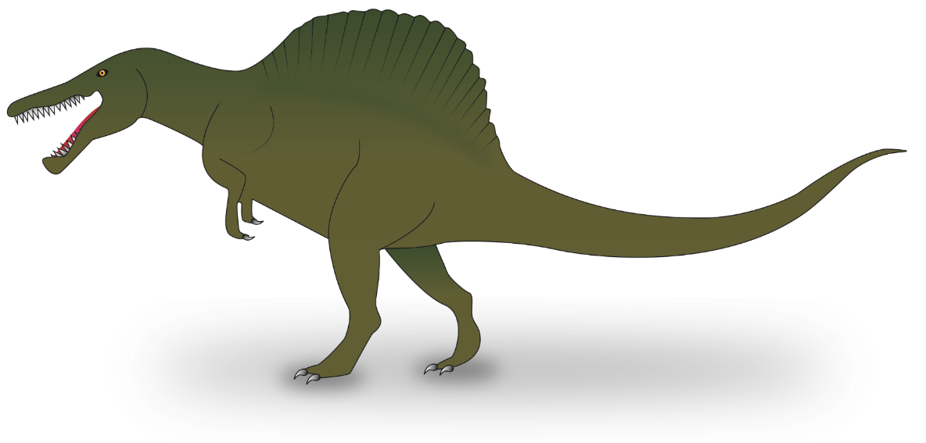

|  |
| --- |
|  |

Dinosaur Facts

Stegosaurus



|  |
| --- |
|  |

Dinosaur Facts

Tyrannosaurus Rex

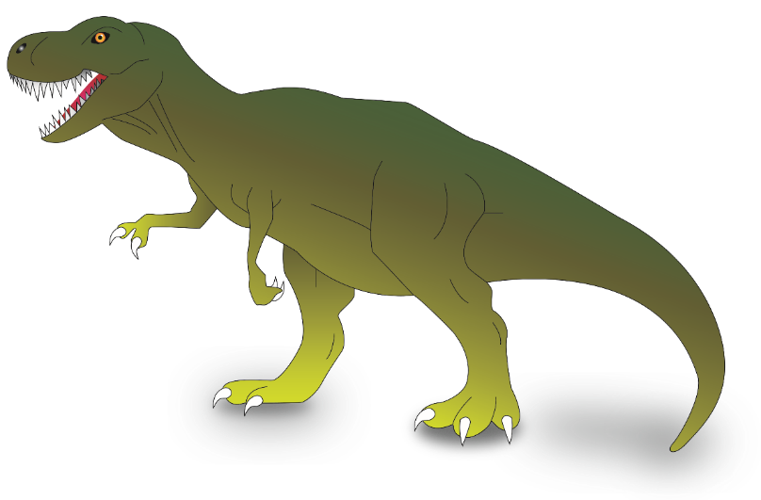

|  |
| --- |
|  |

Dinosaur Facts

Triceratops



  
  
  