Count the Sides Instructions

You need the numbered tiles and a pile of coloured counters each.

- Muddle up the tiles and spread them out face down.
- Take turns to turn over a tile.
6

- Read the number and then look at the shapes.
- You are looking for a shape with that number of sides.

- If you picked number 4, you have a choice of two shapes.
4
square or rectangle

- If you picked number 1, you must choose the circle.
1
circle

- Read the number and then look at the shapes.
- Put a counter of your colour beside that shape on the SHAPE PICTURES.

Your aim is to get at least one counter beside each shape on SHAPE PICTURES and three counters beside one of the shapes.

SHAPE PICTURES
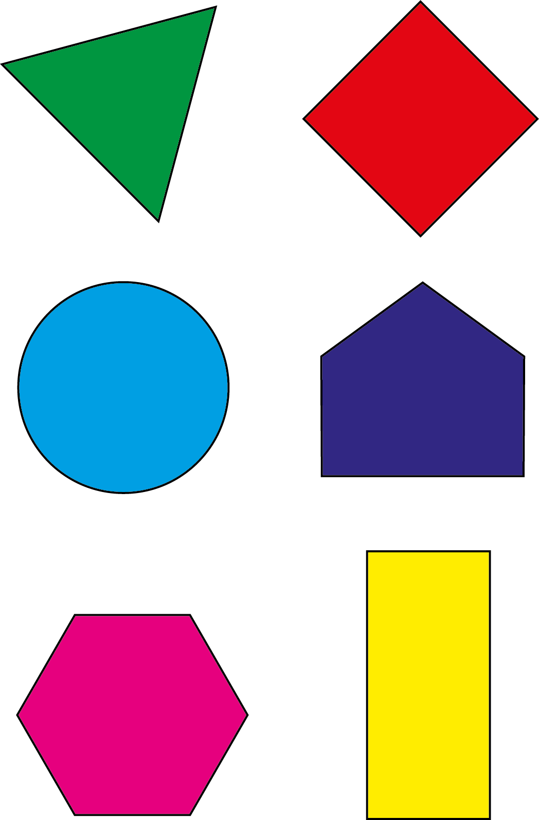

Number Tiles
