Animal Races
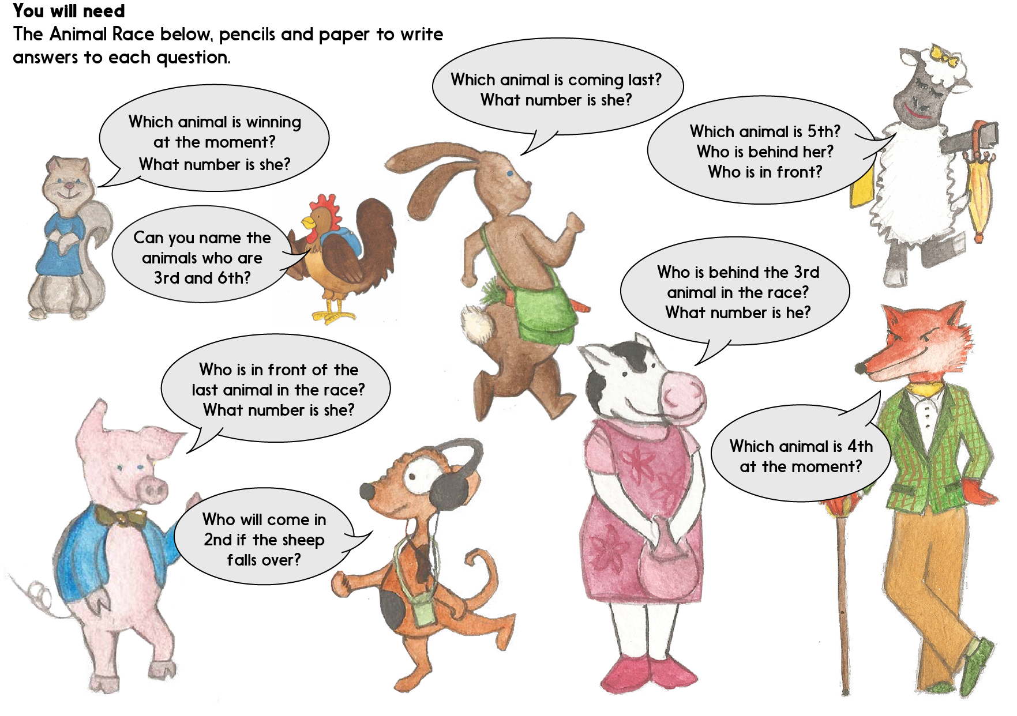

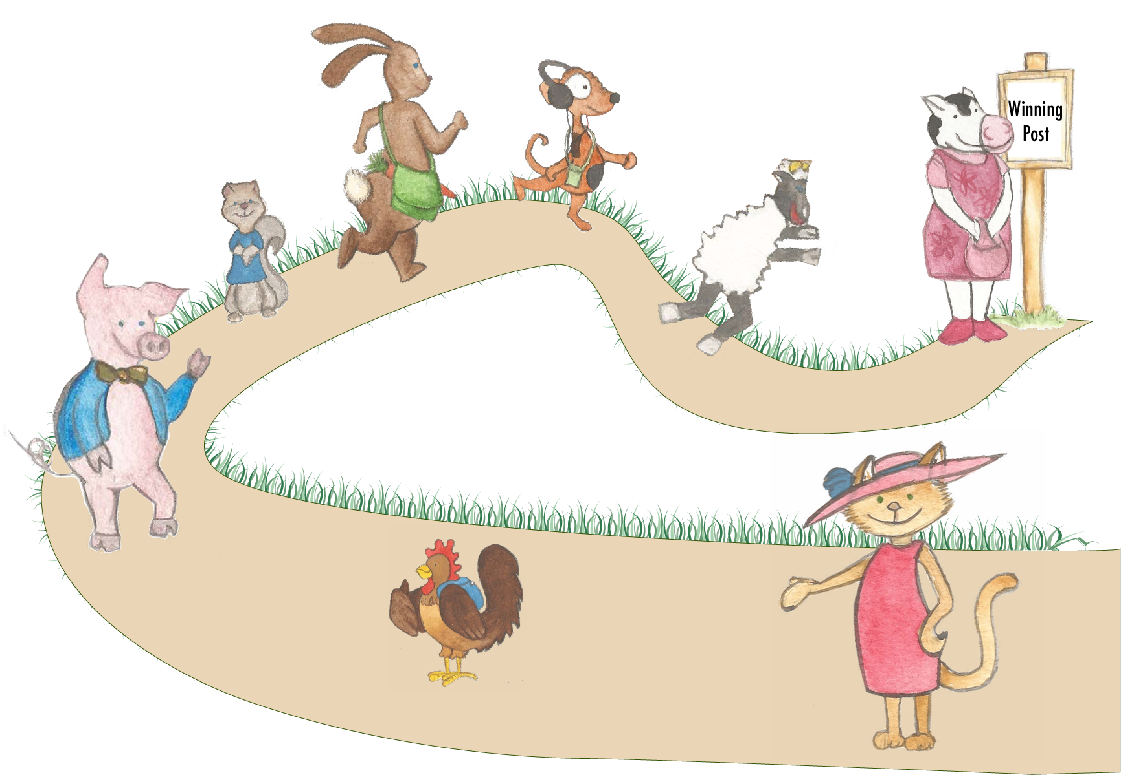
Animal Race

Animal Race Answers

Squirrel question: Which animal is winning at the moment?
Cow is winning. She is 1st.

Rabbit question: Which animal is coming last?
Cat is last. She is 8th.

Fox question: Which animal is 4th at the moment?
Rabbit is 4th.

Chicken question: Can you name the animals who are 3rd and 6th?
Dog is 3rd and pig is 6th.

Cow question: Who is behind the 3rd animal in the race?
Rabbit is behind Dog. Rabbit is 4th.

Pig question: Who is in front of the last animal in the race?
Chicken is in front of Cat. Chicken is 7th.

Sheep question: Which animal is 5th? Who is behind her? Who is in front?
Squirrel is 5th. Rabbit is 4th and Pig is 6th.

Dog question: Who will come in 2nd if the sheep falls over?
If sheep falls over, then Dog would be 2nd.

