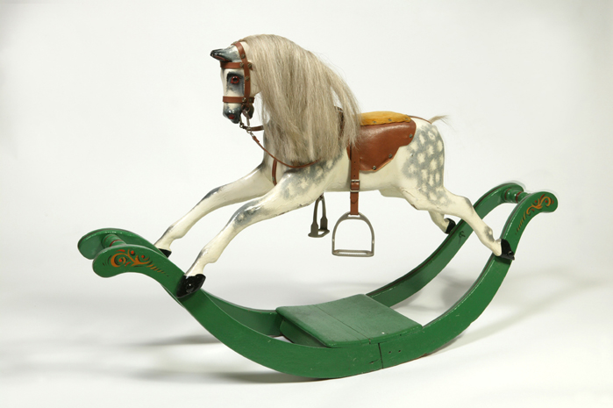**A Rocking Horse**

Image taken from: <http://www.bbc.co.uk/schools/primaryhistory/victorian_britain/toys_and_games/teachers_resources.shtml>