**A Big Mess!**

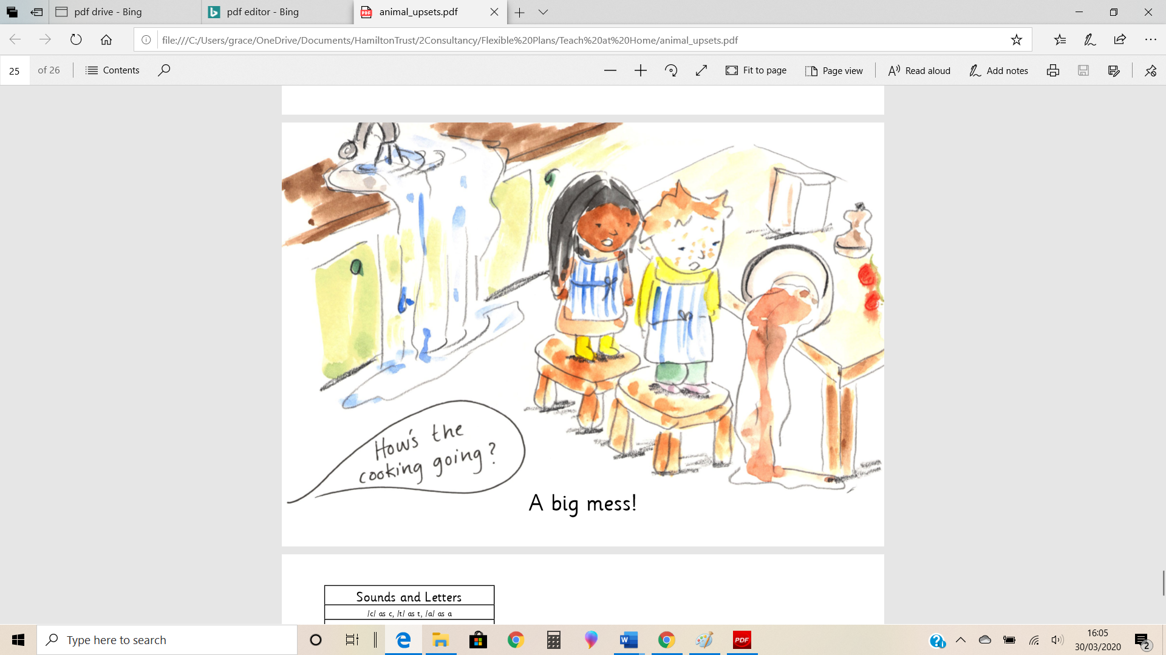

**What are they saying?**

